Brief introduction:
This analysis looks at the performance of single objective and multi-objective algorithms across 8 problem instances, including two categories of problem instances, MaxCoverage, MaxInlfuence. Each problem instance were run thirty times with a population size of 50, where each instance ran was 10,000 function evaluations. The plots demonstrate the mean and standard deviation across the 10,000 function evaluations and graphs their performance, along side with the performance of algorithms from exercise 2.
The problem instances are as follows:
- MaxCoverage: 2100, 2101, 2102, 2103
- MaxInfluence: 2200, 2201, 2202, 2203

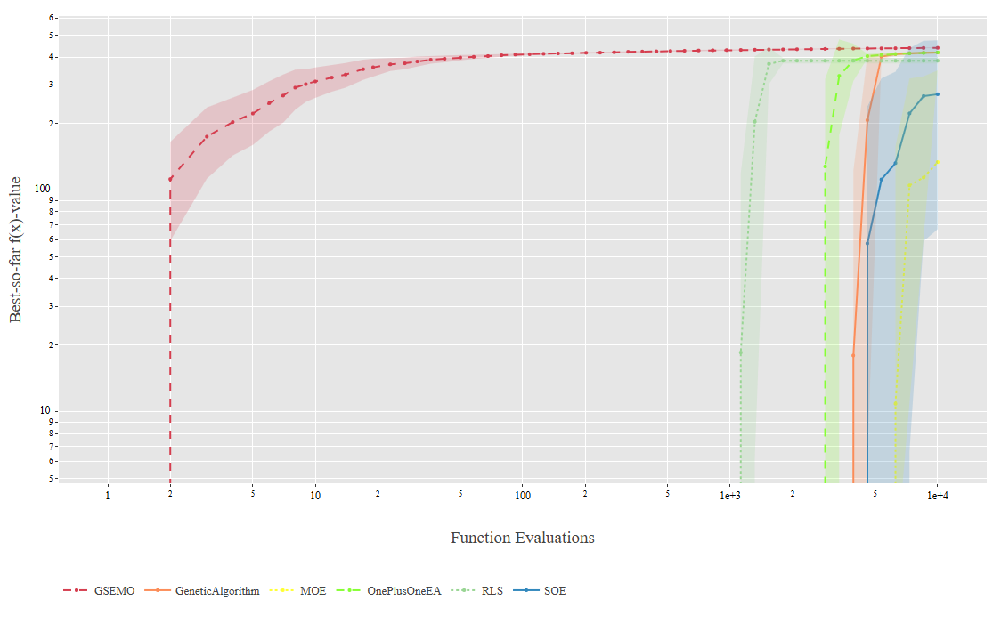
Problems 2100s: There is a common trend in the 2100s problem instances. GESMO performs best. SOE does better than MOE, both not converging, with SOE having high variance.
Problem instance 2100: In this problem instance, GESMO clearly dominates early, reaching near optimal fitness and stabilises smoothly. The multi-objective and single objective algorithms for exercise 3 starts later and increases slowly, seemingly not converged by the last evaluation. Noticeably, single objective algorithm improves more rapidly than multi-objective algorithm, likely due to not needing to balance costs. However, the variance for SOE is much larger than MOE.
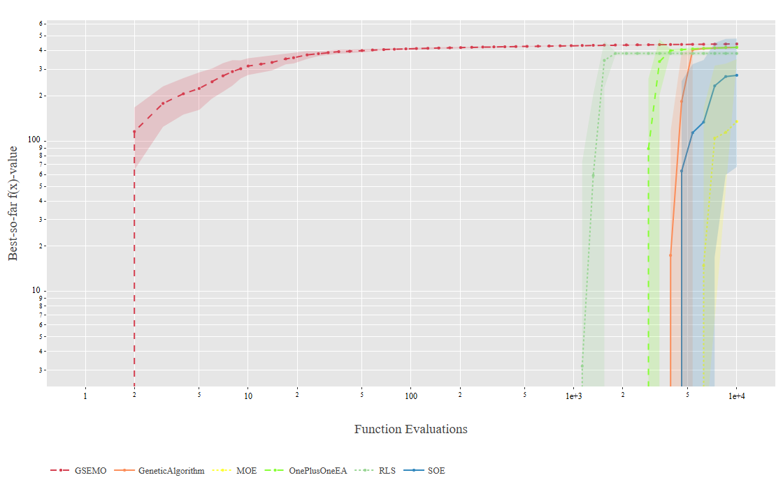

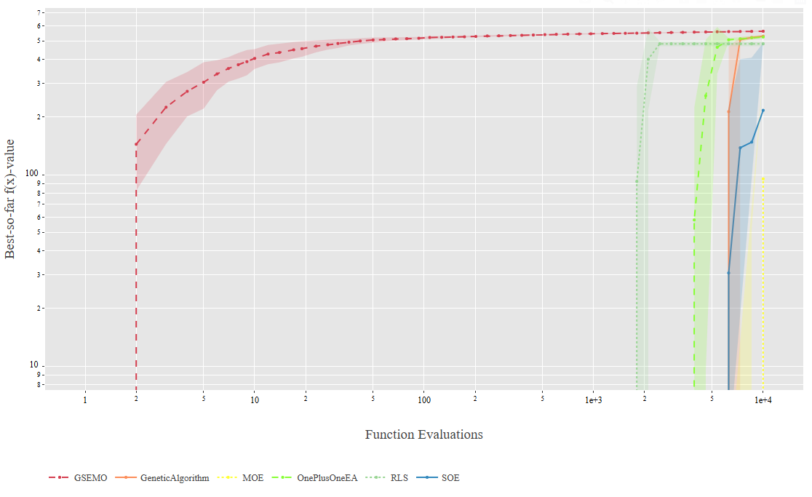
Problem Instance 2101: Once again GESMO performs best, reaching convergence and stabilises early. The exercise 1 algorithms (RLS, (1+1)EA, GA) performed better than SOE and MOE from exercise 3, as they reached convergence and showed little variance. The trend with SOE and MOE remained same as instance 2100, with SOE dominating over MOE, not having reached convergence, with SOE having high variance.
Problem Instance 2102: The trends for this instance is mostly similar to the previous two. GESMO dominates, and the first exercise algorithms improved very quickly, early-on, with littler variance. SOE did better than SOE, though both of them still didn’t reach convergence. SOE showed less variance, and MOE shows very little variance just like in previous instances.
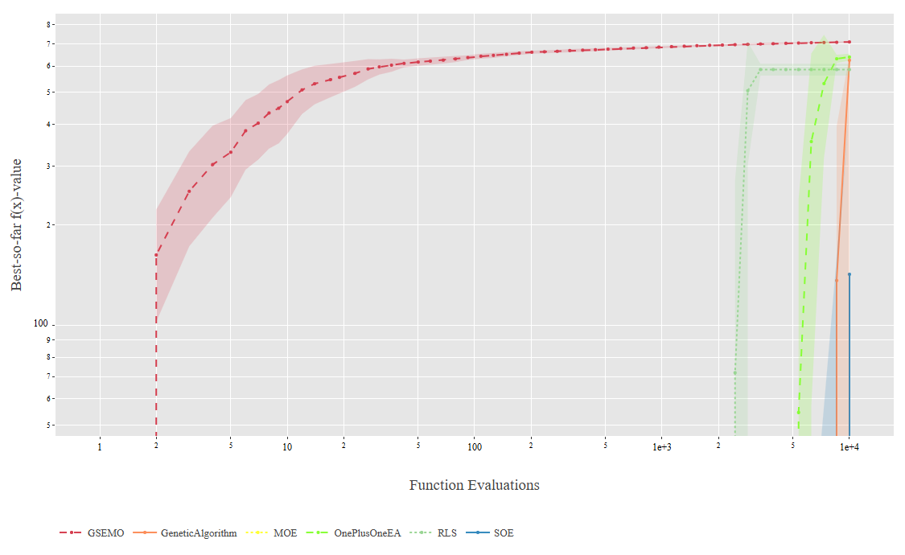
Problem Instance 2103: The trends for this problem instance is more gradual than the previous three. GESMO still dominates, with SOE and MOE still performing worse, without converging. However, MOE and SOE performed similarly, with the SOE showing much less variance in this instance.
Problems 2200s: All problem instances seem nearly identical, with a clear trend, with SOE performing better than MOE, and GESMO dominating.
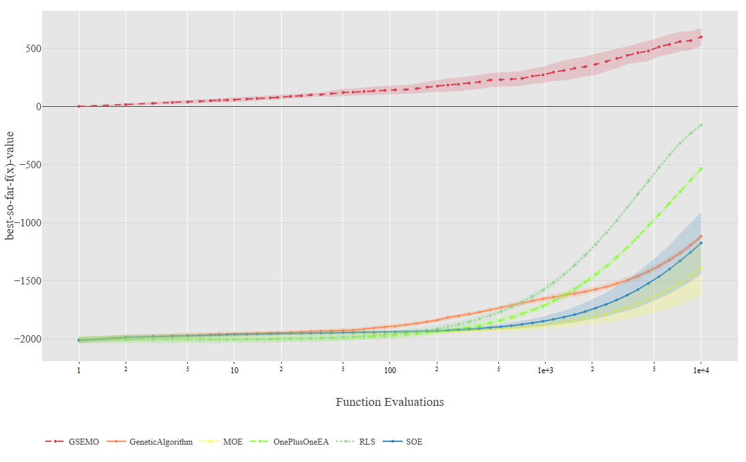

Problem Instance 2200: GESMO dominates, improving slowly throughout the budget. The rest has a steeper rise but improved later in the budget, with MOE performing worse than SOE. Both SOE and MOE has similar variance. RLS performs much better than (1+1)EA and the GA, all showing little variance.
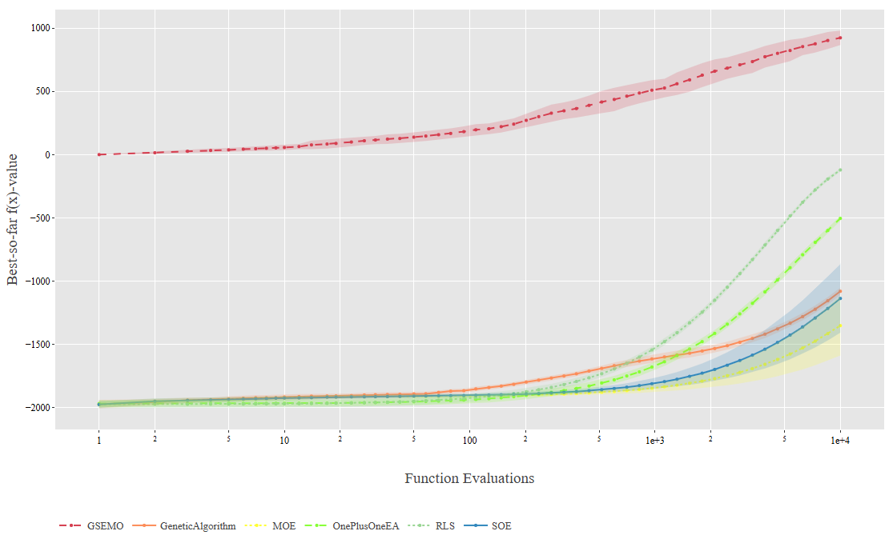
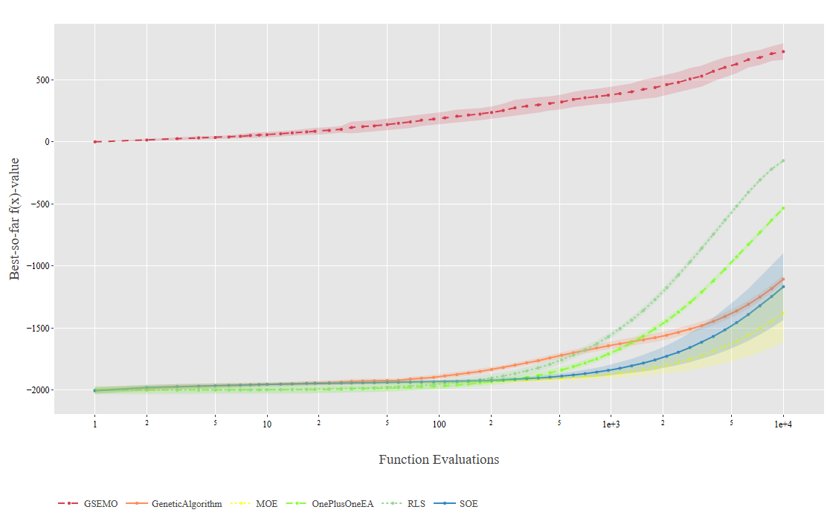
Problem Instance 2201: The trend for this problem instance is near identical to instance 2200. Once again, GESMO dominated, with MOE performing worst. Variance for MOE and SOE seem unchanged, still with RLS performing second best. The first exercise algorithms had little to no variance.

Problem Instance 2202: Once again, the trends is near identical, with GESMO dominating. SOE and MOE remained on bottom. With first exercise algorithms performing in the middle, all with improvements showing later in the budget.

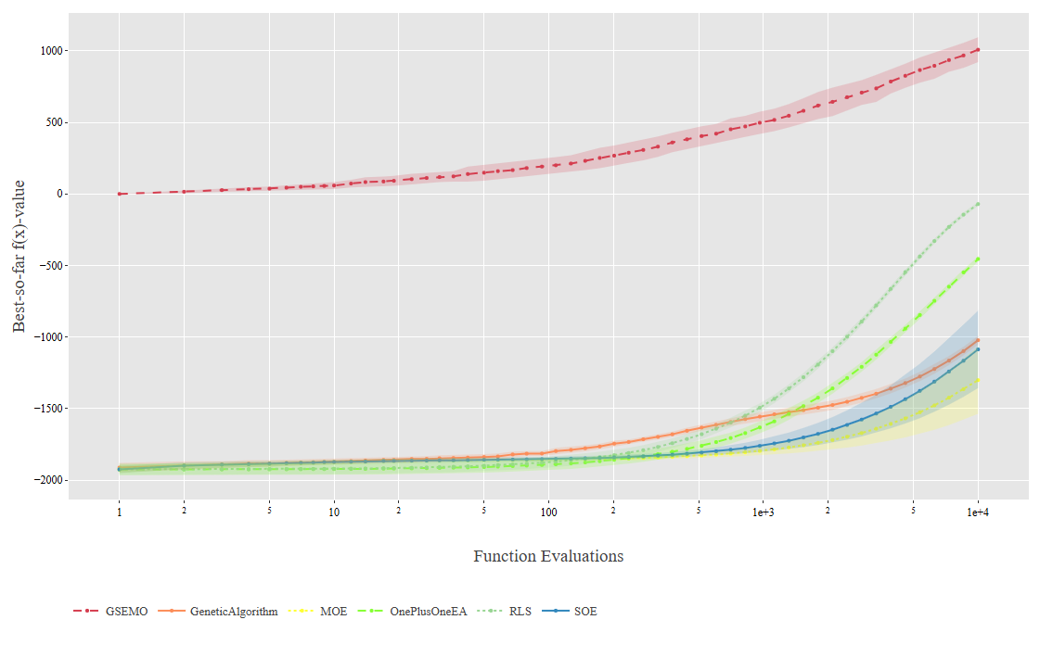
Problem Instance 2203: The trends are identical to the first three instances:

Brief Analysis:
GESMO came best in all cases most likely since it is designed to simultaneously optimize multiple objectives, by maintain Pareto front.
RLS would come second likely due to its deterministic nature once initialized and generates close to good solution, it will climb the hill very quickly. The (1+1)EA and GA doesn’t do as well due to their nature of relying of crossovers and mutations. They do explore broadly, but their selection pressure can cause premature convergence.
The reason why SOE outperformed MOE would be due to MOE focusing on more objectives than OSE, slowing convergence. SOE’s single objective lead to faster convergence, meaning that it’s advantage here is not needing to balance other objectives. However, SOE ended up with more variance due to lack of diversity control, as which region it lands on heavily rely on random initialization. It also doesn’t have Pareto preservation, discarding alternative high-quality backup solutions.
In summary, SOR and MOE performed significantly worse than all others as SOR’s single objective nature lead to premature convergence, causing it unable to escape local minima, where MOE’s overemphasis on maintaining diversity diluted selection pressure and effective exploitation.

